Maria Merino

2nd Phase Challenge:

Section 0 - Introduction
- What is the intended purpose and potential advantage of learning object oriented design?
The purpose and potential advantage of learning objective oriented design is to build and better applications, have a better understanding on what you intend to do, and get your code written faster with less bugs and less bugs and more flexibility.
- Why might it be advantageous to analyze and design before beginning programming?
It’s advantageous to analyze and design before beginning programming because it is important to know first what we need to create and this is accomplished by the analysis phase where it’s important to know ‘what we need to do’. Design means we need to plan what we need to do which is also important to determine how we are going to do them. When we have a full understanding of the analysis and design phases, then the easier the programming would be.
- What is the difference between a "waterfall" and an "agile" approach to development? What is iteration and how do we to use them to build software?
Waterfall methodology is an earlier approach used that uses a linear sequential approach where each developmental phase can only begin when the previous phase has been completed. This methodology does not normally work for software development because it needs features to fix bugs or support continual development. Agile approach, on the other hand, is a much more effective approach used as an alternative to the waterfall methodology where it provides opportunities to evaluate the direction of a project throughout the SDLC process. This is achieved through iteration where work cycles are repeated, reviewed and then improved in the next iteration. This is widely seen in software development where we can also get feedback from users after presenting sketches or blueprints of their product.
The difference between the two methodologies is that with the waterfall approach, once you have completed a stage, you cannot go back since it’s harder to change based on both time and user needs. This can only be fixed by designing a new system entirely, which can be very costly and time consuming.
Section 1 - Core Concepts
- What are the various types of programming languages and in which domain is each used?
Types of programming languages are: Logic programming language (Prolog), functional programming language(Haskell), and Object-oriented programming languages such as C++, Java, Perl, JavaScript, Perl, Python, PHP, C#, JavaScript, Objective-C, and Ruby (and many more).
- Describe in your own words the three properties of a computing object.
Three properties include identity, attributes, and behavior. Any object is an entity that consists of attributes, identity, and behavior. Identity is what makes them unique, attributes is what the objects have and behavior is what the object does.
- Explain how classes are analogous to blueprints. Include the relationship between a class and an object. Can you think of how the analogy breaks down?
A class is a blueprint, a definition, or a detailed description from which individual objects are created. First, we write the class and use it to create an object. We make a blueprint before we can build an object. Each class describes two things: attributes and behavior.
- When a developer uses the term "abstraction" what are they describing?
Abstraction describes the essential qualities of an idea rather than one specific example. It also means we automatically discard what’s irrelevant.
- What does encapsulation prevent? What does it enable?
Encapsulation prevents the data and code from being accessed by anyone outside the class. For this reason, it would serve as a protective barrier where access to data and code are controlled by an interface.
- Describe the inheritance relationship between classes. When would this relationship be advantageous to establish?
The relationship between an inheritance and classes is that inheritance allows creating classes that are derived from other classes. That means they automatically include some of its ‘parents’ members in addition to using its own.

- What is the basic idea behind polymorphism? How can it make the classes we create more flexible?
The idea behind polymorphism is the ability for different objects to respond to identical messages. Polymorphism allows us to create one universal method, which makes the classes and programs we create more flexible.

Section 2 - Object-Oriented Analysis and Design
- What are the steps of analysis that come before writing code for an application? Why do you think these steps make writing the code easier?
Five steps include: gather your requirements, describe the app, identify the main objects, describe the interactions, and create a class diagram. This would make writing our code easier because these processes will identify the classes for our application.
- What should you have after you've completed the first phase of defining your requirements?
We should have an idea of what an app is required to do or what should an app do.
- What is UML? Why is it useful to visualize your application before coding it?
Unified Modeling Language (UML) is a visual language specifically for drawing diagrams of an objected-oriented system. Visualizing your application before coding it is important to ensure that the program design meets and supports the requirements for robustness, scalability, and other characteristics.

Section 3 - Utilizing Use Cases
- Write a use case for creating an event on your phone's calendar.
Title: Add an event
Actor: User, Server
Scenario:
- User goes to the Calendar tab to create an event on his phone’s calendar.
- User clicks the Add Event Button, which loads the entry event page.
- User fills in the data.
- User submits the data on the server.
- Server saves and adds the new event to the mobile device.

- Can you think of a use case for a mobile application in which the actor is not the user of the mobile device?
Any external entity that acts on our system such as another computer system (ACMESystem), an anonymous visitor to the application, or a client such as a browser running on the device are one of the use case for mobile application in which the actor is not the user of the mobile device.
- Write another use case for a mobile device user interacting with a calendar application. This time include a couple extensions when crafting your scenario.
Title: Sync Google Calendar with mobile device
Actor: User
Scenario:
- User wants to sync Google calendar with the mobile device
- User clicks Settings and opened the Mail, Contacts, Calendars tab
- User selected and added the Gmail account
- User entered account information
- User selected the Calendars option and tapped save.
- Account is added to the mobile device and syncing will automatically begin.
Exceptions:
4. The user entered an invalid password. An ‘Invalid Password’ is displayed on the screen.
5. User did not click the Calendar option. Calendar cannot be synced.
6. Issues with Recurring Events. Imported recurring event may not sync. Only recurring events created within Google calendar will sync correctly.

- Do a Google image search for "use case diagram." Notice how many variations there are. What do they all generally have in common?
They represent a simple overview of multiple use cases and actors at the same time to see how they interact with each other.
- Write 5 user stories to describe a mobile user interacting with his or her maps application.
As a mobile user, I want to test if my maps application works so that I can start using them.
As a mobile user, I want to use the indoor maps so that I can see a detailed floor plan for select hotels, airports, or stores.
As a mobile user, I want to disable audio mapping so that I can still hear the music playing on my radio.
As a mobile user, I want to set my location on a map from my mobile device even without a GPS so that maps for mobile can tell me approximately where I am from my phone.
As a mobile user, I want to activate voice command when entering a location so that I can be safer while driving.

Section 4 - Domain Modeling (Modeling the App)
- Identify the classes in the use case you constructed for a user interacting with his or her calendar application in chapter 3.
Classes are: User, Calendar, Event, Data, Server, and Mobile device
- Identify the relationships among the classes you found above. Create a conceptual model where you diagram these relationships and then upload a picture of your model below.
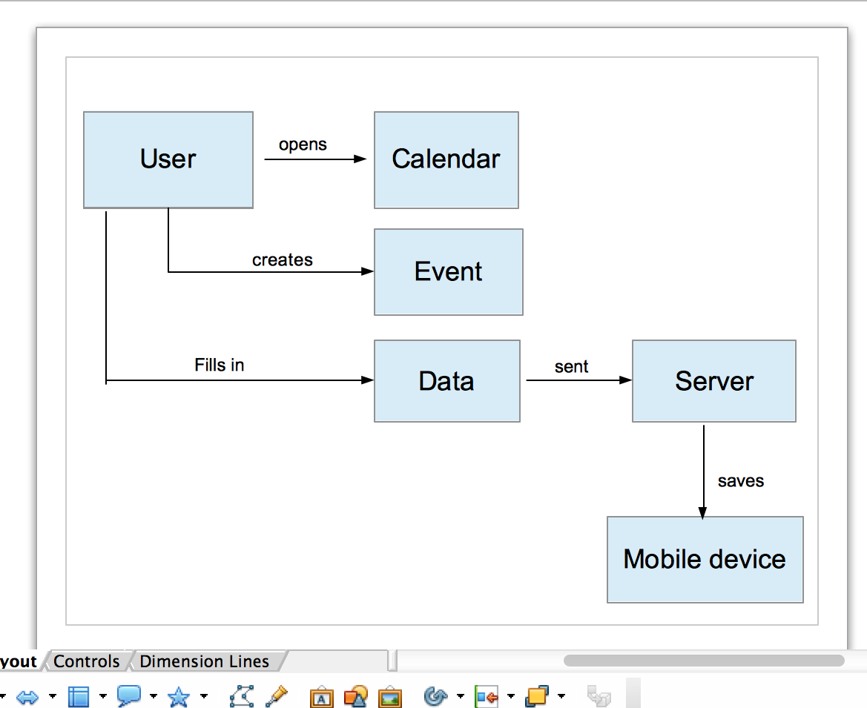
- Identify the responsibilities of the classes you found above. List them here.
Display calendar, display event, process data, connect server, and confirm saved data.

Section 5 - Creating Classes
- Construct Class Diagrams for the classes you imagine exist in a twitter app, a maps app, a calendar app, or any other app you would like to make. Do you find that it is easier to come up with the attributes or with the behaviors? Why do you think that is?
It’s easier to determine the attributes than behaviors. This is because it is easier to describe the characteristics of an entity/object than determining what actions each object in the class is responsible for exhibiting or performing.
- How might the separation of interface and implementation in Objective-C be an advantage when working with class diagrams?
Since Objective-C is much more complex where classes are split into two sections of code called the interface and the implementation. Both serve as an advantage when working with class diagrams because interface would say what methods exists while implementation is where methods would be defined.
- Recall from Stage 1: What are the constructors and destructors in Objective-C? Why do we use them?
A constructor in Objective C is by creating ‘init’ method in the class. Destructor in Objective C is delete obj. Both are important special member functions used to construct and destroy objects where constructing may involve initiation of objects or memory allocation while destructing may involve deallocation of memory or cleaning up for objects.
- Like the interest rate example in the video, give three additional examples of data that would be the same for all instances of a class.
Three additional examples of data that would be the same for all instances of a class are starting_pay_rate, final_pay_rate, and initial_list

Section 6 - Inheritance and Composition
- Describe in your own words what inheritance is and how it is useful when constructing classes.
Inheritance identifies that there is a shared attribute and behavior among classes. The objects in the inheritance hierarchy follows an ‘is a’ relationship with their class they have inherited from.

- Referring to the apps on your phone, come up with three examples where you believe methods are being inherited from superclasses and called by subclasses.
Examples include: Place a call, open iTunes, send a message.

